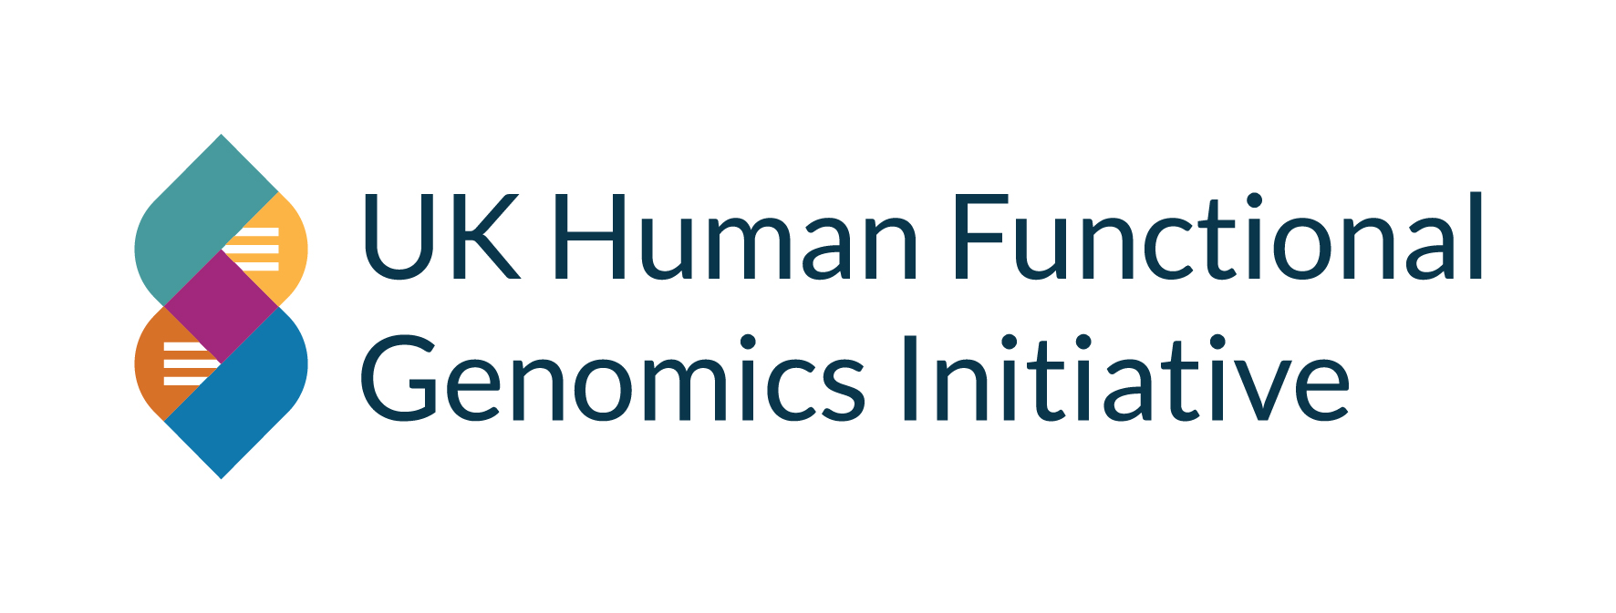
Academic–Industry Partnership Award
Application Form

1. Applicant Details
Primary Applicant Name
Primary Applicant Email
Primary Institution
Co-applicants, emails & institution
2. Industry Partner Details
Company Name
Primary Industry Contact Name
Primary Contact Email
Number of Employees
Company Website URL
3. Project Information
Project Title | Maximum 150 characters (including spaces)
Project Duration | 3–12 months
Scientific Case for Support | Maximum 1,000 words.  Include: Background, Aims & Objectives, Methodology, Data Analysis Plan.  State final word count at end of section.
Industry Partner Contribution | Maximum 500 words.  Clearly define company role, resources and integration.
Data Management & Sharing Plan | Maximum 300 words.  Include data generation, storage, security and FGx DCC integration.
Strategic Alignment with FGx | Maximum 300 words.  Explain alignment with FGx priorities and ecosystem contribution.
Long-Term Impact & Sustainability | Maximum 300 words.  Describe translational trajectory and follow-on funding strategy.
4. Financial Information
Total Funding Requested (£15k–£100k)
Budget Breakdown
Industry Cash Contribution (£)
Industry In-Kind Contribution (Estimated £)
5. Intellectual Property Management Plan | Maximum 300 words.  Outline ownership, protection and exploitation strategy.

